Software Requirements Specification

Q5
Norris Cotton Cancer Center/Dartmouth College

DOCUMENT REVISION HISTORY
Version Number | Date | Description
1.0 | 06/15/2005 | - Draft constructed by David Jewell
1.1 | 07/05/2005 | - OHSU Revised

Background/Summary
1st Draft
2nd Draft
Redefined type of user from Bioinformatics to Biostatistician and clarified that the application will be able to work both stand alone and through spectra checkout.

Table of Content
Requirements Specification 1
Q5 1
Background/Summary 1
1 Introduction 4
1.1 Overview 4
1.2 Related Documents 6
2 Actors and Goals 6
2.1 Bioinformatic specialist and Researcher 6
2.2 Mass spectroscopist 6
3 Use Cases 7
3.1 Current Q5 use case (legacy level) sample classification 7
3.1.1 Use Case Model 7
3.1.2 Brief Description 7
3.1.3 Primary Actor 8
3.1.4 Preconditions 8
3.1.5 Basic Flow of Events 8
3.1.6 Special Requirements 8
3.2 Q5 use case sample classification 9
3.2.1 Use Case Model 9
3.2.2 Brief Description 9
3.2.3 Primary Actor 9
3.2.4 Secondary Actors 9
3.2.5 Preconditions 10
3.2.5.1 Only for spectra DB recall scenario. LIMS system must be able to accept authentication of users for Q5 based check out and annotate spectra. 10
3.2.6 Basic Flow of Events 10
3.2.7 Postconditions 10
3.3 Q5 use case spectra quality control 10
3.3.1 Use Case Model 10
3.3.2 Brief Description 10
3.3.3 Secondary Actors 11
3.3.4 Preconditions 11
3.3.4.1 LIMS system must be able to accept authentication of users for Q5 based annotation of spectra 11
3.3.4.2 LIMS system must be able to accept authentication of users for Q5 based annotation of spectra 11
3.3.5 Basic Flow of Events 11
3.3.5.1 No Special Requirements 11
4 Overall Requirements 11
4.1 Requirements Prioritization 11
5 Data Definitions 12
6 Sign Off 13
6.1 Approval 13

Introduction

Overview
The Q5 application is a probabilistic classification algorithm that employs principal components dimension-reduction and linear discriminant analysis.
Q5 has shown utility in disease classification of expression-dependent proteomic data from mass spectrometry of human serum. Q5’s ability to classify complex fragment mixtures was evaluated by testing its ability to discriminate the mass spectra of healthy vs. disease human serum samples. The two disease states examined in testing were ovarian and prostate cancer. Existing screening methods for both cancers carry a low positive predictive value (PPV). When detected early, the 5-year survival rate increases for both cancers.
Q5 outputs a classifier (discriminant) capable of classifying new mass spectra into one of the classes. The new spectra (called test spectra) that have not been seen by the algorithm and their classifications are unknown to the algorithm; the goal of the Mass Spectra Classification Algorithm (MSCA) is to determine the correct classification based on the classifier constructed from the training set. Classification verification is the testing process by which the discriminant is evaluated for its ability to correctly diagnose test samples. MSCAs can be characterized by the type of MS data processed, type of algorithm employed, and method of classification verification used.
Completeness of mass spectrum. Analysis may be performed on either complete or partial mass spectra. Complete mass spectra consist of the relative intensities of all m/z values acquired during MS data collection. This includes the relative intensities observed for all m/z values from 0 up to the upper limit of detection. An MSCA that processes complete mass spectra works with the entire recorded spectra: no values are “manually” excluded through preprocessing. When portions of a spectrum are excluded from consideration, we say a partial spectrum is generated.

5

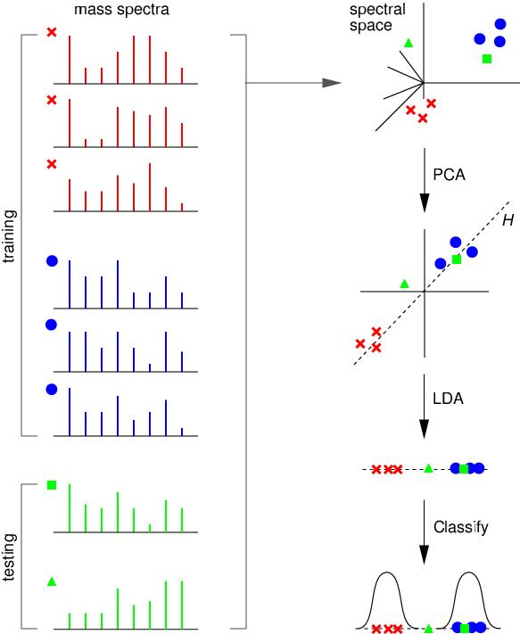

F6i6g6u6r6e6 616:6 6M6a6j6o6r6 6S6t6e6p6s6 6o6f6 6t6h6e6 6Q656 6A6l6g6o6r6i6t6h6m6.6 6T6h6e6 6s6t6e6p6s6 6i6n6v6o6l6v6e6d6 6i6n6 6b6u6i6l6d6i6n6g6 6a6 6t6w6o6-6c6l6a6s6s6 6c6l6a6s6s6i6f6i6e6r6 6a6r6e6 6i6l6l6u6s6t6r6a6t6e6d6 6u6s6i6n6g6 6s6i6m6p6l6i6f6i6e6d6 6a6r6t6i6f6i6c6i6a6l6 6s6p6e6c6t6r6a6.6 6O6n6 6t6h6e6 6l6e6f6t6 6a6r6e6 6t6r6a6i6n6i6n6g6 6(6x6,6 •6)6 6a6n6d6 6t6e6s6t6i6n6g6 6(,666 ∆)6 6s6p6e6c6t6r6a6.6 6S6h6o6w6n6 6o6n6 6t6h6e6 6r6i6g6h6t6,6 6f6r6o6m6 6t6o6p6 6t6o6 6b6o6t6t6o6m6,6 6a6r6e6 6(616)6 6t6h6e6 6s6p6e6c6t6r6a6l6 6s6p6a6c6e6 6r6e6p6r6e6s6e6n6t6a6t6i6o6n6 6o6f6 6e6a6c6h6 6s6p6e6c6t6r6u6m6;6 6(626)6 6P6C6A6:6 6t6h6e6 6r6e6s6u6l6t6 6o6f6 6d6i6m6e6n6s6i6o6n6a6l6i6t6y6 6r6e6d6u6c6t6i6o6n6 6(6f6o6r6 6s6i6m6p6l6i6c6i6t6y6 6w6e6 6s6h6o6w6 6t6h6e6 6p6r6o6j6e6c6t6i6o6n6 6o6n6t6o6 6j6u6s6t6 6t6h6e6 6t6o6p6 6t6w6o6 6p6r6i6n6c6i6p6l6e6 7c7o7m7p7o7n7e7n7t7s7)7;7 7(737)7 7L7D7A7:7 7t7h7e7 7p7r7o7j7e7c7t7i7o7n7 7o7f7 7e7a7c7h7 7s7p7e7c7t7r7u7m7 7o7n7t7o7 7t7h7e7 7d7i7s7c7r7i7m7i7n7a7n7t7 7s7u7r7f7a7c7e7 7H7;7 7a7n7d7 7(747)7 7t7h7e7 7p7r7o7b7a7b7i7l7i7s7t7i7c7 7c7l7a7s7s7i7f7i7c7a7t7i7o7n7.7 7I7n7 7t7h7i7s7 7e7x7a7m7p7l7e7 7t7h7e7 7t7e7s7t7i7n7g7 7s7p7e7c7t7r7u7m7 7d7e7n7o7t7e7d7 7b7y7 777 7i7s7 7c7l7a7s7s7i7f7i7e7d7 7a7s7 7b7e7l7o7n7g7i7n7g7 7t7o7 7t7h7e7 7c7l7a7s7s7 7d7e7n7o7t7e7d7 7b7y7 o7,7 7w7h7i7l7e7 7t7h7e7 7s7p7e7c7t7r7u7m7 7d7e7n7o7t7e7d7 7b7y7 ∆777 7i7s7 7u7n7c7l7a7s7s7i7f7i7e7d7.7

Heuristic vs. Exact Classification Algorithms. Heuristic classification algorithms include approaches such as genetic algorithms, neural networks, and simulated annealing. These algorithms generally require multiple iterations to converge to a classifier; furthermore, the solution found by heuristic algorithms is not guaranteed to be optimal. In addition, many heuristic approaches are non-deterministic. Even when run on the same training set, the same non-deterministic algorithm often converges to a different discriminant. In contrast, MSCAs that utilize closed-form exact solutions (CFES) compute an exact solution using closed-form equations. CFES algorithms are computationally efficient; they are non-iterative and deterministic (i.e., always compute the same solution). Linear Discriminant Analysis (LDA), and thus Q5, are CFES algorithms.

Related Documents
The Q5 distribution contains a set of Matlab (Mathworks Inc, Natick, MA) functions. Q5 is written entirely in Matlab.
Reference: Ryan H. Lilien, Hany Farid, and Bruce R. Donald. "Probabilistic Disease Classification of Expression-Dependent Proteomic Data from Mass Spectrometry of Human Serum." Journal of Computational Biology, 10(6) 2003, pp. 925-946.

Actors and Goals

Bioinformatic specialist and Researcher
Bioinformatic specialist is the primary actor and default user. They data mine spectra and combination of spectra. The user is a basic system actor that can submit spectra to Q5 for analysis as well as check out or download data from a MS compatible LIMS databases.

Mass spectroscopist
Mass spectroscopist is a primary actor. They test and assess spectra quality. The user is a basic system actor that can submit spectra to Q5 for analysis as well as check or download data from a MS compatible LIMS database.

Use Cases

Current Q5 use case (legacy level) sample classification

Use Case Model
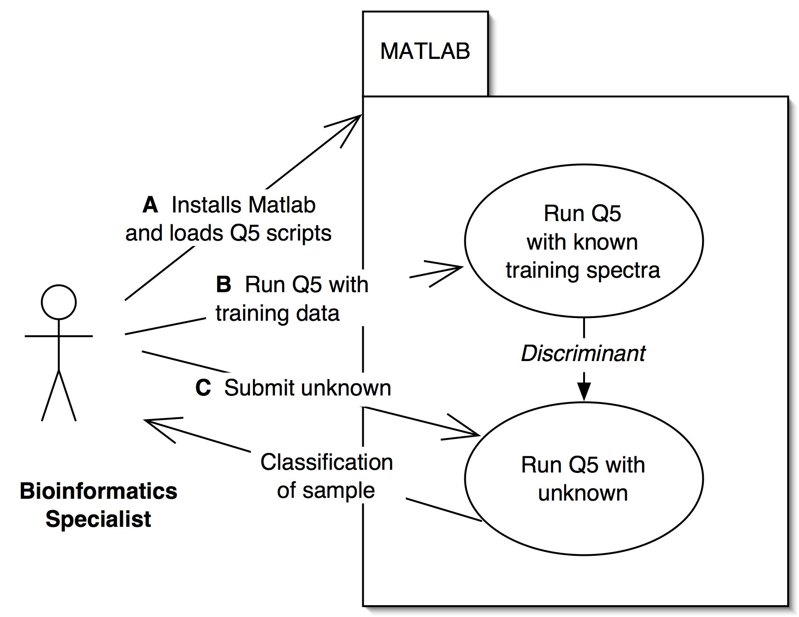

Brief Description
Currently
- Biostatistician specialist obtains and installs Matlab from Mathworks Inc. on personal computer. User downloads current Q5 scripts written in Matlab language from web site http://www.cs.dartmouth.edu/~donaldlab/Software/Q5_Dist.tar.gz, installs them within Matlab as instructed in the ReadMe.txt file also included in the distribution.
- User manually loads data set for training of Q5
- User loads unclassified spectra for Q5 classification.

Primary Actor
Biostatistician specialist

Preconditions
Matlab Installed

Basic Flow of Events

User submits training data sets for discriminant construction
User submits unknown spectra for classification

Special Requirements

In order for successful classification to occur the quality of both the training set as well as the unknown should be at a level that is not yet quantifiable.

Issues in usability and architecture:
- Format conversion
- Local license and install of Matlab that does not resemble a federated model of application usage.
- Accounting of user workflow and usage of data treatments does not occur within the application.
- Standardized output for clear understanding by user for significance of evaluation has not been engineered

Q5 use case sample classification

Use Case Model
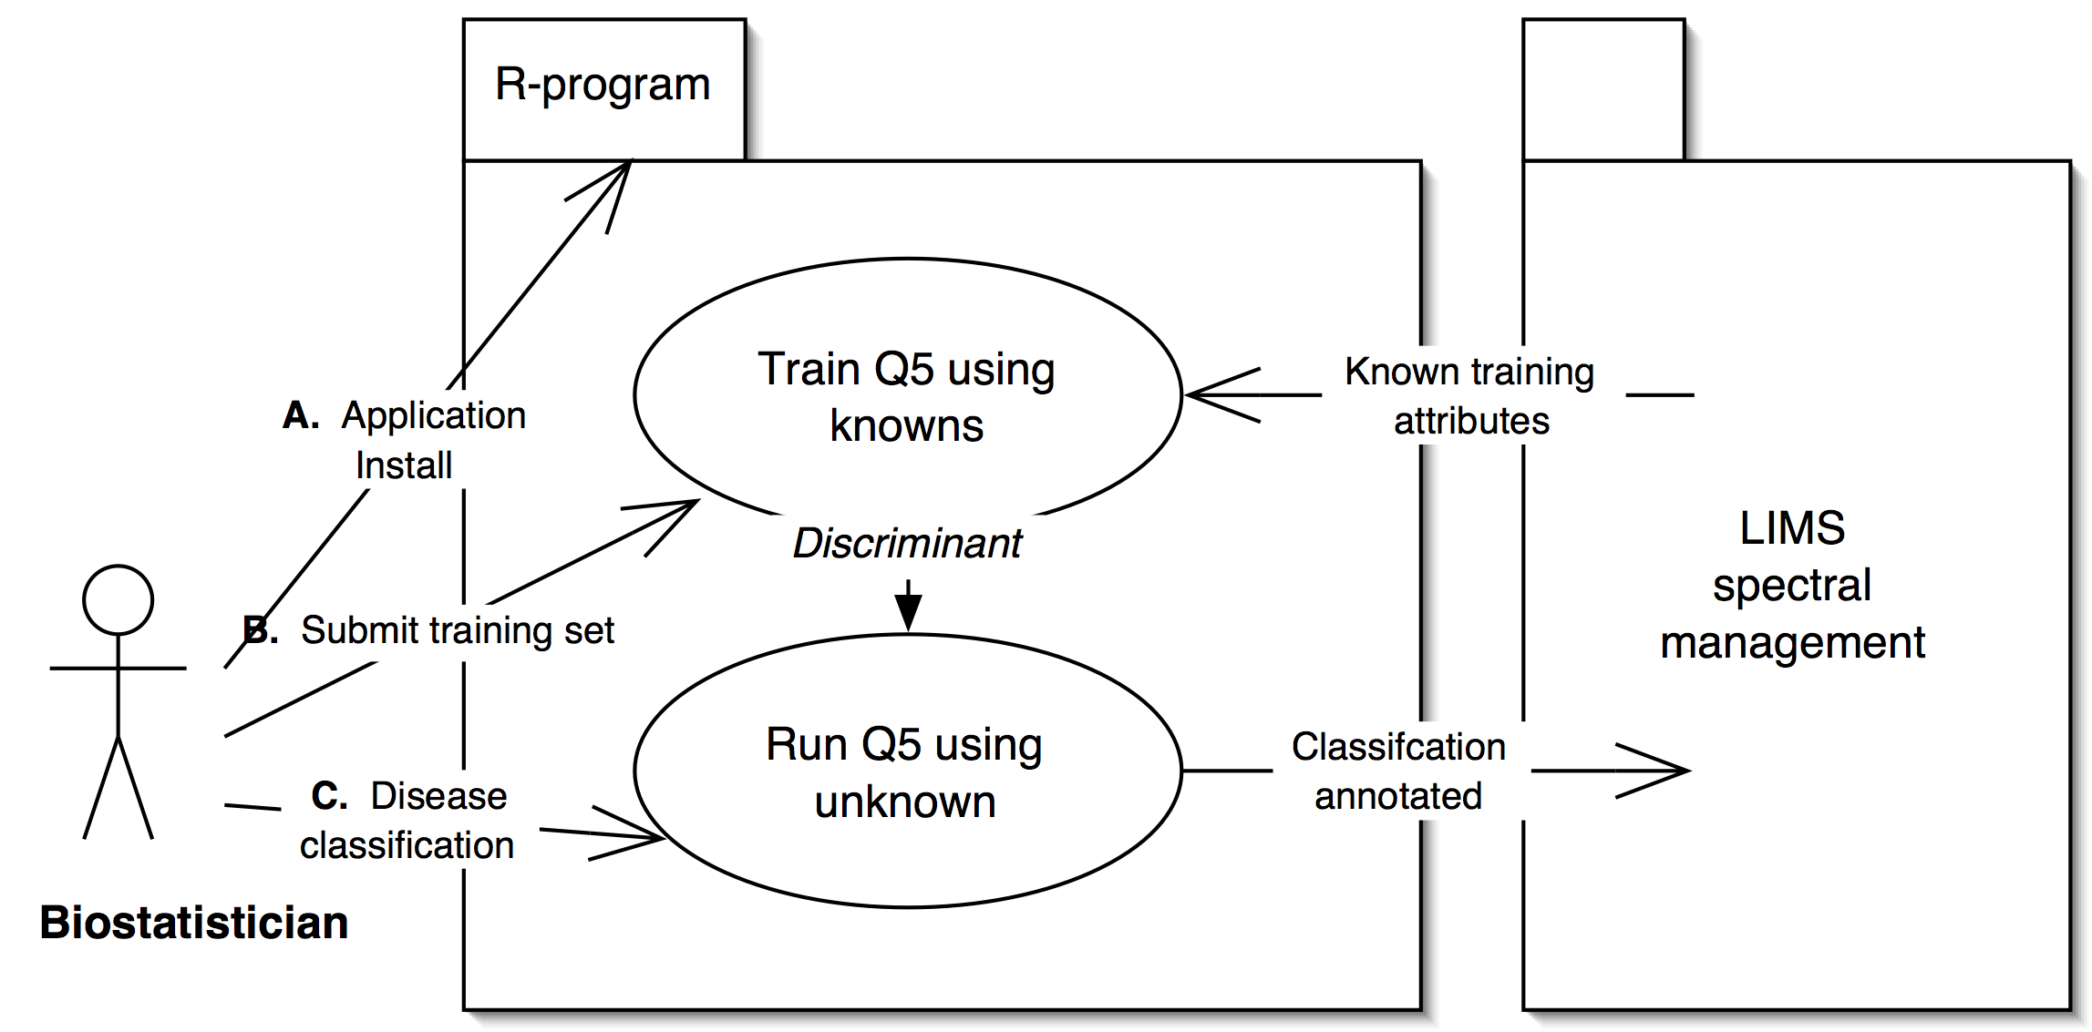

Brief Description
    - Biostatistician installs R program and Q5 plugin.
    - Generates discriminant with submitted (or spectra DB recalled) training data set of spectra.
    - Submits unknown spectra for classification and generates evaluation for annotation of spectra.

Primary Actor
Biostatistician specialist is the Primary Actor of this case.

Secondary Actors

Automated evaluation of spectra already in database set up by primary actor

Preconditions

Only for spectra DB recall scenario. LIMS system must be able to accept authentication of users for Q5 based check out and annotate spectra.

Basic Flow of Events

User submits training data sets for discriminant construction
User submits unknown spectra for classification

Postconditions
Classification is annotated to spectra

Q5 use case spectra quality control

Use Case Model
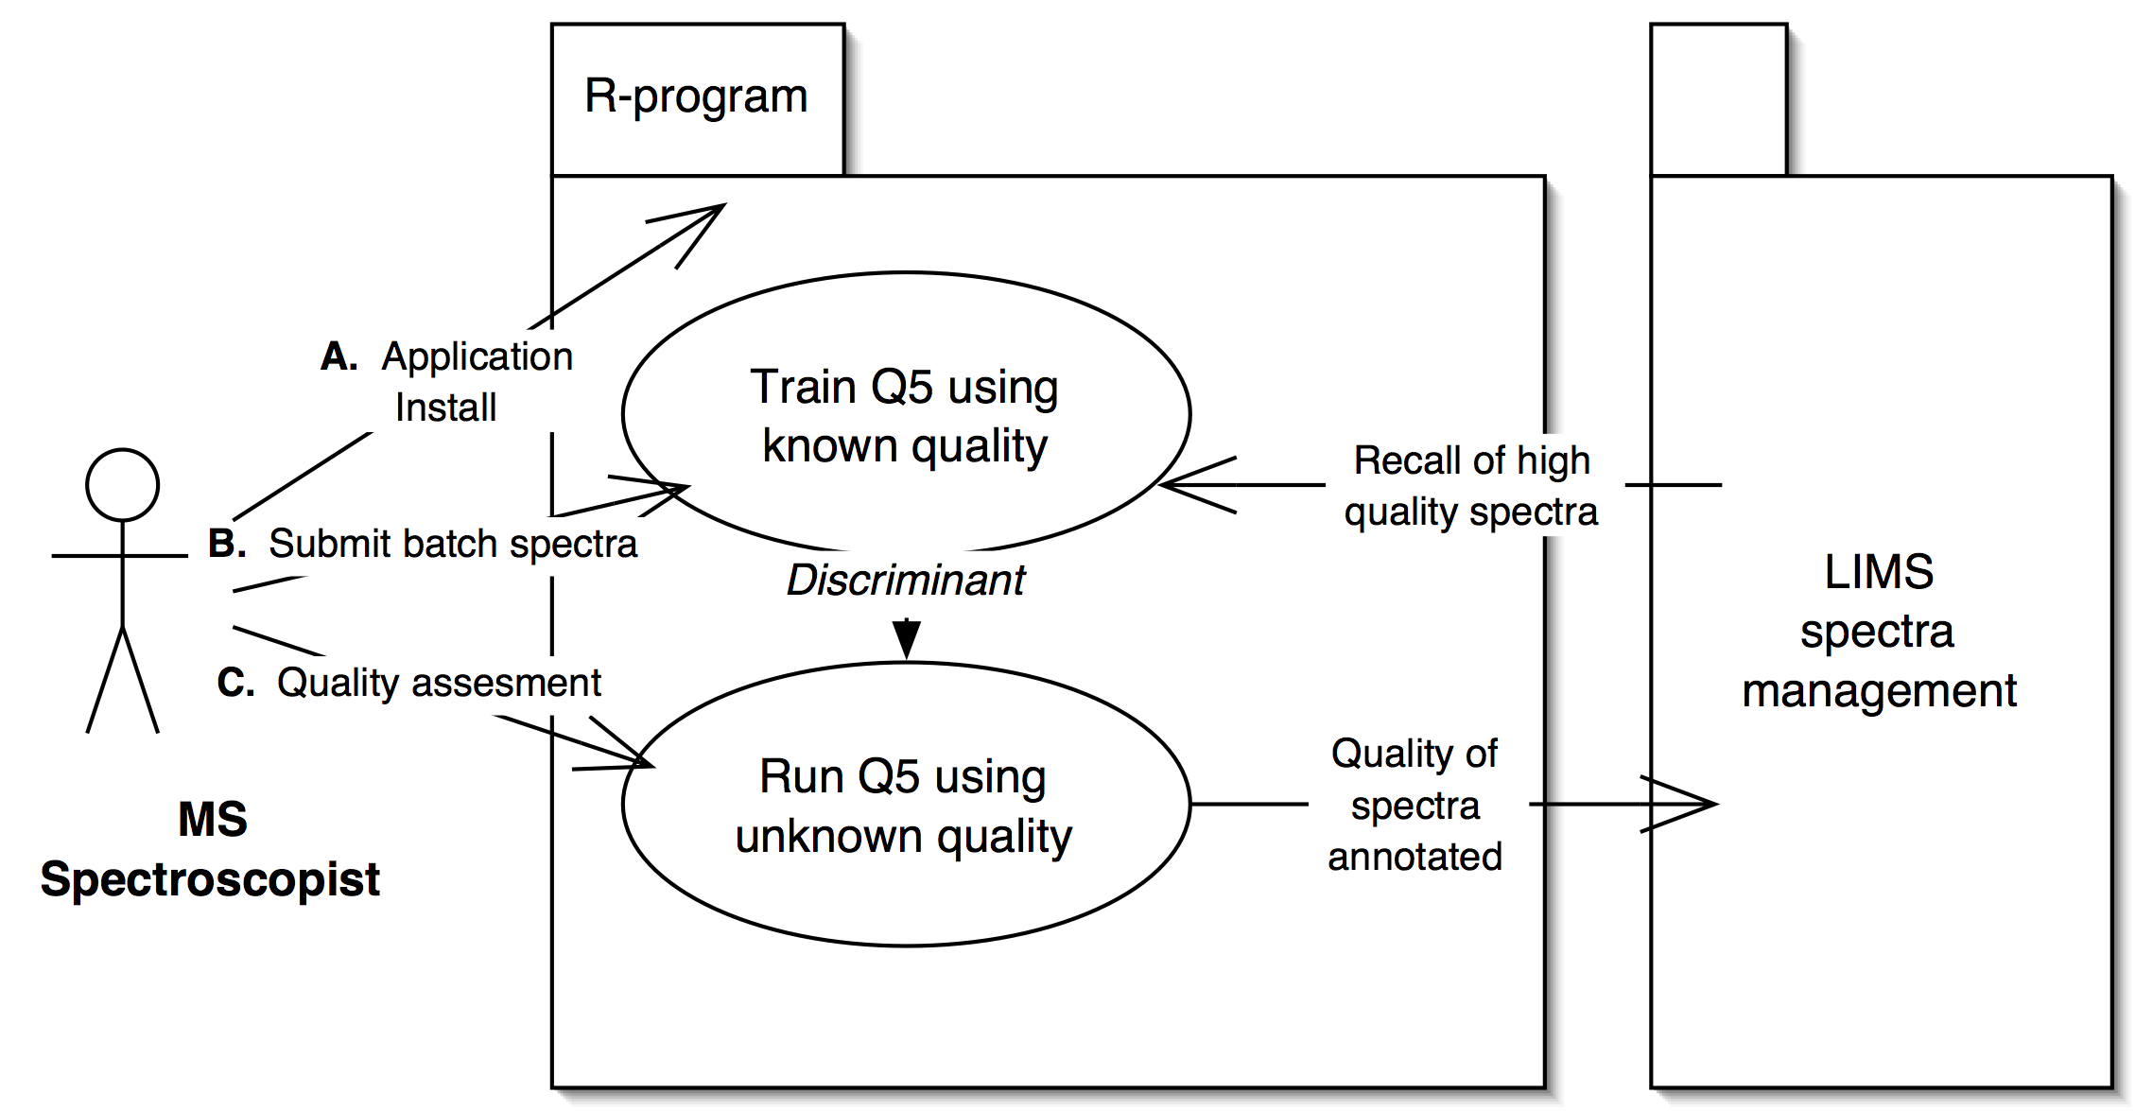

Brief Description

    - Primary actor installs R and Q5 plugin.
    - Primary actor submits and or recalls batch spectra for training and generating the discriminant.
    - Primary actor classifies unknown spectra for quality.

Secondary Actors

Automated evaluation of spectra quality relative to already in database set up by primary actor.

Preconditions

LIMS system must be able to accept authentication of users for Q5 based annotation of spectra

LIMS system must be able to accept authentication of users for Q5 based annotation of spectra

Basic Flow of Events
User (Mass spectroscopist):
Selects or submits data set as standard for comparison
Submits unknown spectra for quality assignment
Makes determination based on Q5 categorization

No Special Requirements

Overall Requirements

Requirements Prioritization

Priority | Use Case Name | Supp Requirement Ref #
1 | 3.2 sample classification
2 | 3.3 spectra quality control

Data Definitions
<Under construction>

Sign Off

Approval

Workspace General Contractor Rep Print Name Date
Architecture Workspace Rep Print Name Date
VCDE Workspace Rep Print Name Date
Workspace Working Group Rep Print Name Date
NCICB Rep Print Name Date

